**Setting Up Application Environment**

**Install IBM Cloud CLI**

|  |  |
| --- | --- |
| Date | 10 Nov 2022 |
| Team ID | PNT2022TMID51155 |
| Project Name | Smart Fashion Recommender Application |
| Team  Members: | Karthik Muneeswaran M  Gowtham Prabakar S  Mohammed Sithik M  Muthu Kumar M  Aswanth R |

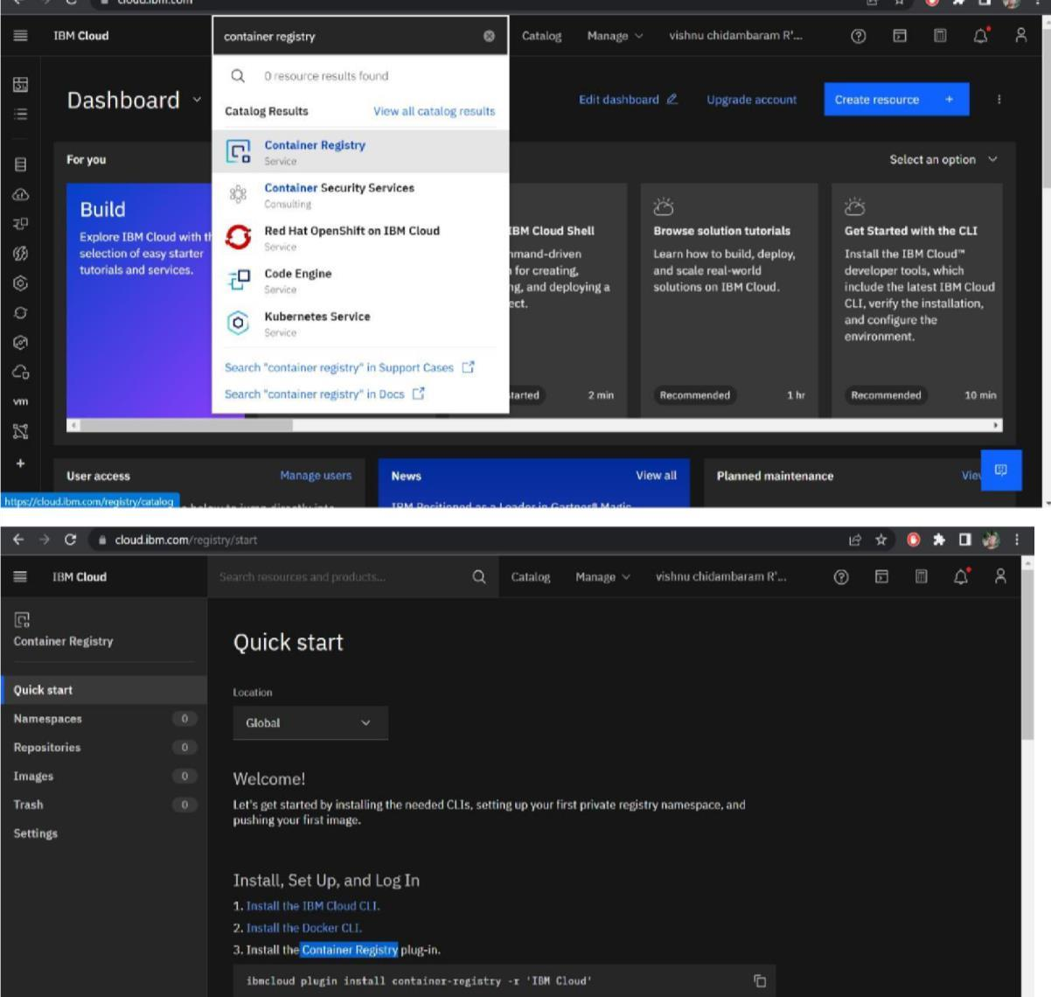

**STEP1:**Login to your IBM Cloud [***https://cloud.ibm.com/login*** and](https://cloud.ibm.com/login) in-search bar you can type

**Container registery** and click to get started.

**Step 2:** Follow and do the step given in this page one by one [***https://cloud.ibm.com/registry/*** ***start***](https://cloud.ibm.com/registry/%20start)

**Step 3:**Run the command in power shell,***(New-Object***

***Net.WebClient).DownloadString('https://clis.cloud.ibm.com***

***/install/powershell')***

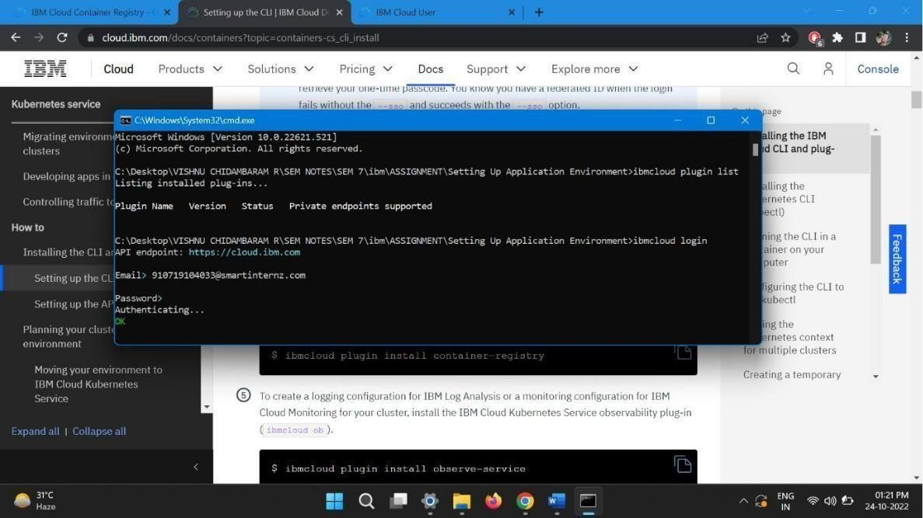

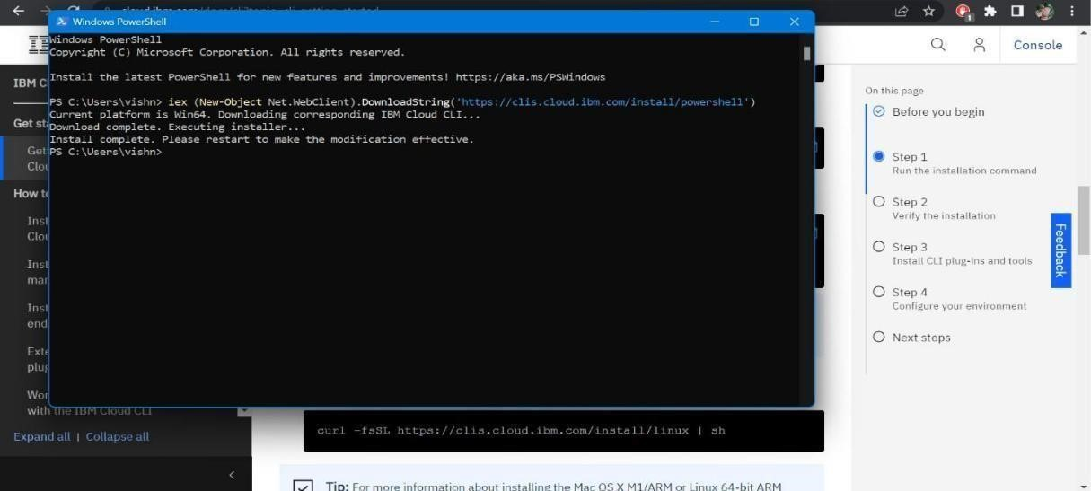

**Step 4:**Enter the command in cmd:

**Step 5:** Run all the command one by one in cmd  [***https://cloud.ibm.com/docs/containers?topic=containe***](https://cloud.ibm.com/docs/containers?topic=container)[***rs-cs_cli_install***](https://cloud.ibm.com/docs/containers?topic=containers-cs_cli_install)

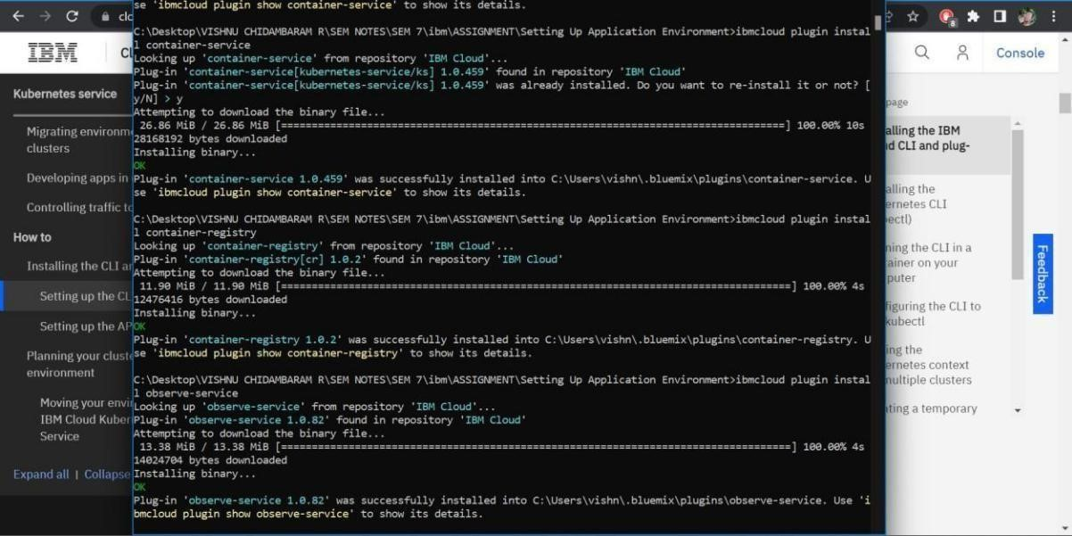

**Step 6:** Finally, you will get the IBM CLOUD CLI in your desktop